Mechanical Overview

Year: 2023 Semester: Fall Team: 16 Project: Air Hockey Robot

Creation Date: September 20, 2023 Last Modified: September 23, 2023

Author: John Morton Email: morton67@purdue.edu

Assignment Evaluation: See Rubric on Brightspace Assignment

* 1. Commercial Product Packaging

This is an analysis of two commercial products that are similar to the air hockey robot. The first product is a DIY open source project that you can make yourself or order the parts online. The second product is

* 1. Product #1

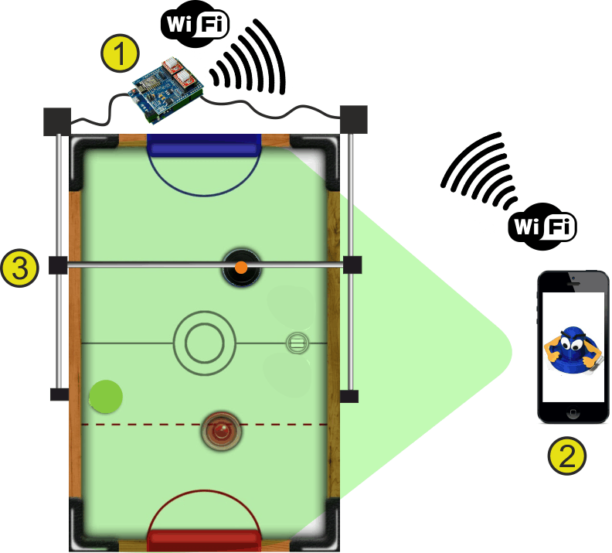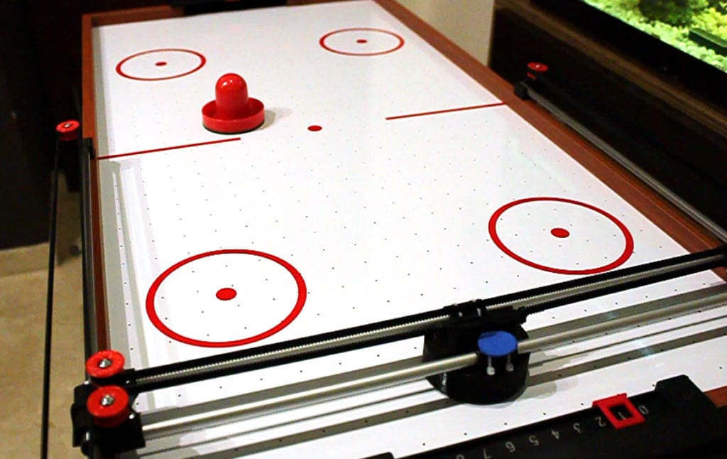

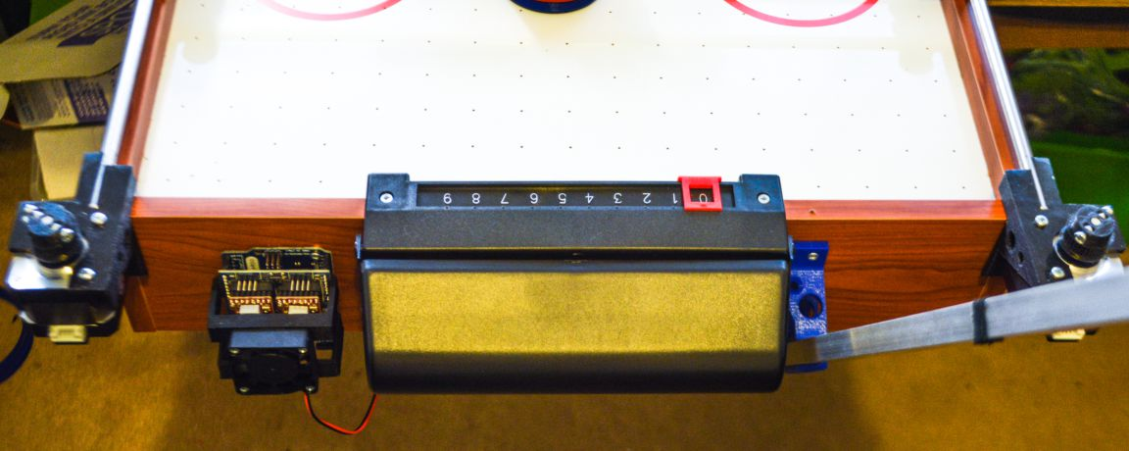

This is an open source product that uses computer vision and a gantry system to control the robot, similar to our project. Mounting packages are created to hold the phone, controllers, and motors in place and attach them to the air hockey table.

The advantages of this is a simpler design that has parts that can be 3D printed and is designed to minimize components. The camera and image processing are all contained in the smartphone which significantly reduces the number of parts. The phone is held in place to reduce variable camera positions and maintain consistency. This robot also uses a 2-pulley gantry system to reduce the force needed on each motor and the number of motors. The arduino controller and the motor controller are both housed in the same PCB, which minimizes the number of external wires needed.

Some downsides are the exposed enclosures as well as the need to screw in the design into the table, which could damage the table if you’re not careful. This build also has its limitations when it comes to speed and power. At a very high level of play, the phone’s camera may not be fast enough to keep up. The table also tends to shake a lot when the motors operate at high speeds, which could affect the phone’s camera and operation.

A lot of the packaging in this design is going to be similar to the packaging we use for our robot. The main difference is how robust the parts we use are and how powerful some of the components will be. The same kind of H-shaped gantry system will be used along with more powerful stepper motors and motor controllers. The camera and computer will be separate and more powerful than what a phone can provide. We will be using an STM32 microcontroller as opposed to the arduino uno that they use in this project. Our robot will also handle the scoring system as well as displaying that information.

* 1. Product #2

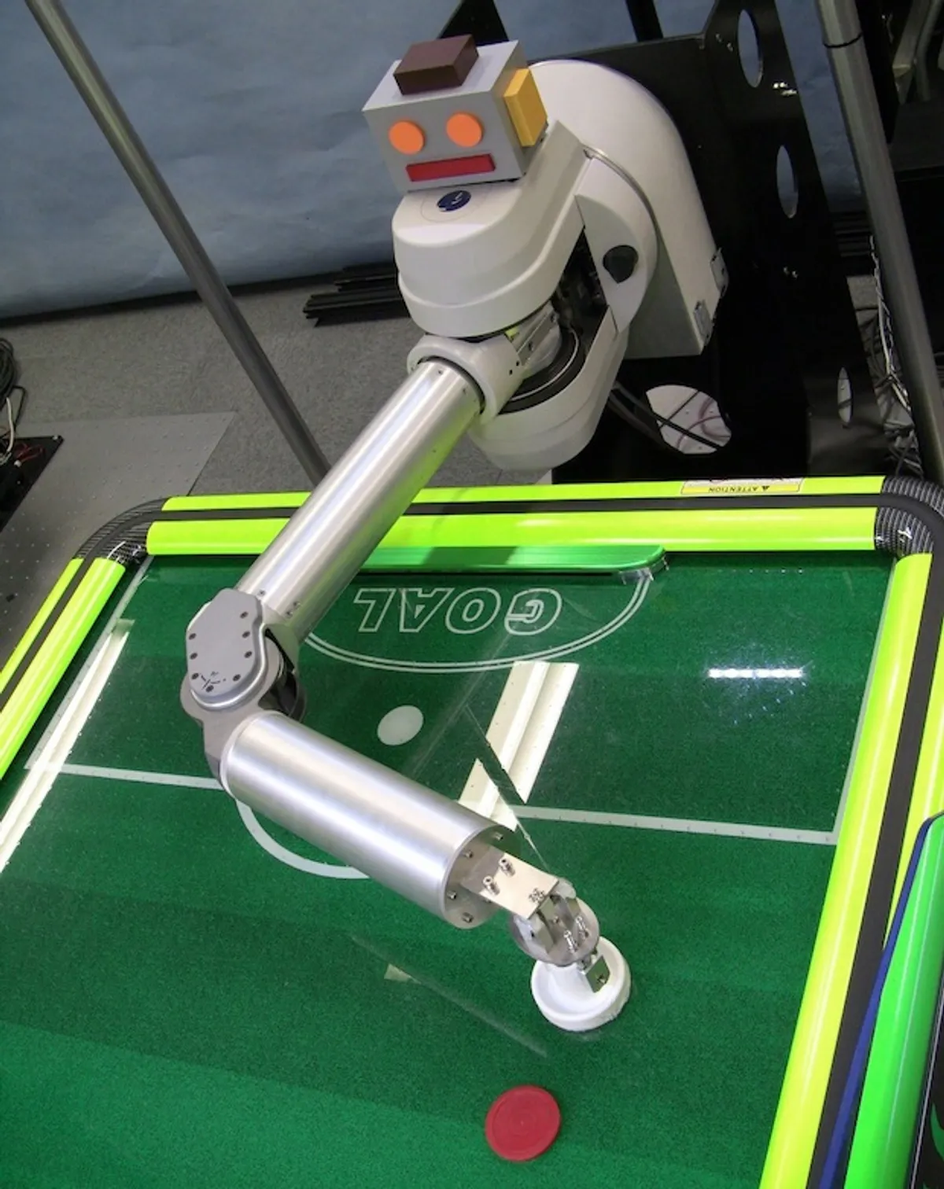

This is another robot that uses a Barrett four-axis robotic arm to handle the arm movement for the mallet. It has adaptive software to adjust how it plays based on how the human player moves.

Some positive aspects of this design are the fact that it uses high speed cameras that can operate at 500 frames per second. This provides plenty of data about the puck movements and what the opponent is doing. The robot has an adaptive playing style, which makes playing against it much more enjoyable. Instead of the robot only playing defense while you put pressure on as an attacker or vice versa, it will vary its approach to keep the game interesting.

There are some disadvantages to this design. The bulky mechanical design doesn’t lend itself to being a viable commercial product. Secondly, using a robotic arm is going to be more expensive than a gantry system and also be a lot more complex to operate.

The packaging for our air hockey robot will adopt some of the adaptive playstyle that this robot has, but not to the extent that this robot does. We will also put some robotic decorations on our robot to give it some personality like this robot has. Our air hockey robot won’t be using a robotic arm like this one and use a gantry system instead. The high speed camera would be great to adopt, but cost limits our use down to a 120 frame per second camera.

2.0 Project Packaging Description

The air hockey table that we will be using can be seen in the figure from Appendix 1. It has a relatively large playing surface to give the robot more time to predict the trajectory of the puck. An H-shaped gantry system will be used to move the mallet around. This keeps the design relatively simple and cost-efficient. A camera is also placed high enough above the table to be able to observe everything that goes on in the table. There is also a newer puck retrieval system in place to keep in line with the new goal location, which also acts as the housing for the break sensor for scorekeeping. The PCB with the microcontroller on it will communicate with the stepper motors via the motor controller and also take in data from the usb port with instructions on how to move said motors. The microcontroller also takes in score data and displays relevant information like the score and time on the scoreboard.

3.0 Sources Cited

[1] “Air hockey robot EVO.” <https://jjrobots.com/product/air-hockey-robot/> (accessed Sep. 24, 2023).

‌[2] FALCONER, JASON. “This Robot Wants to Beat You at Air Hockey - IEEE Spectrum.” *Spectrum.ieee.org*, 13 June 2013, <https://spectrum.ieee.org/japanese-air-hockey-robot>. Accessed 24 Sept. 2023.

Appendix 1: CAD Model Illustrations

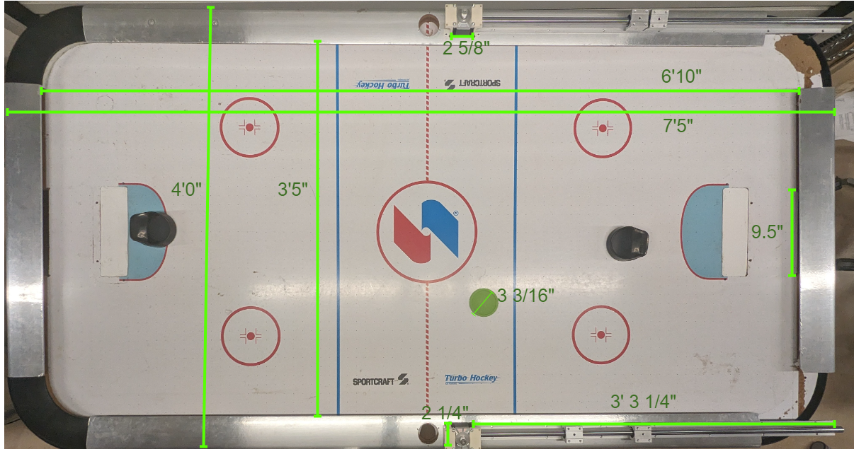

Figure 1

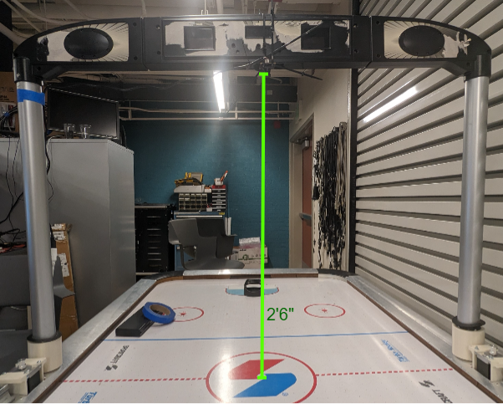

Figure 2

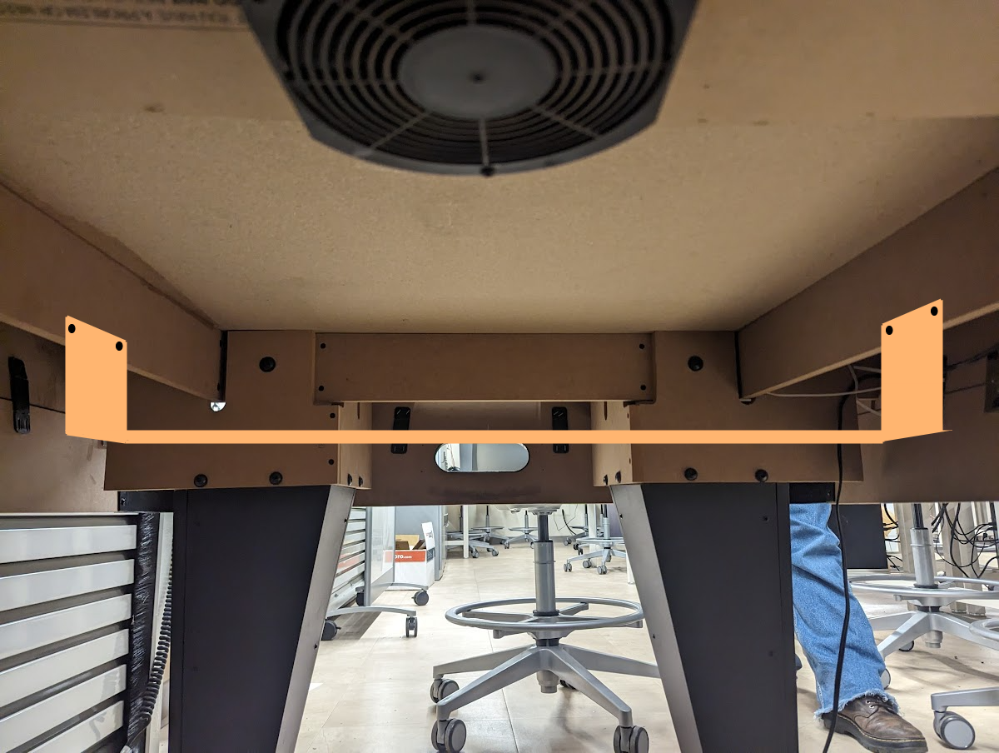

Figure 3

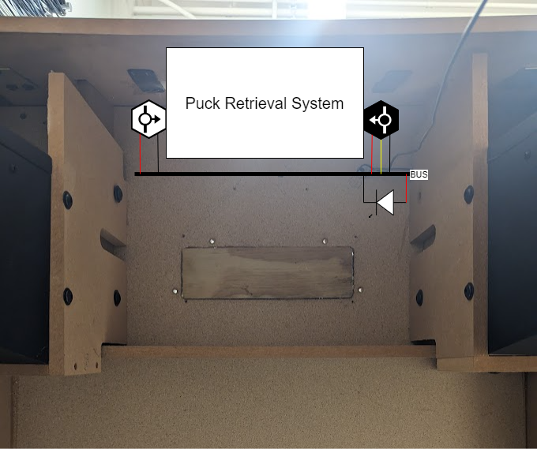

Figure 4

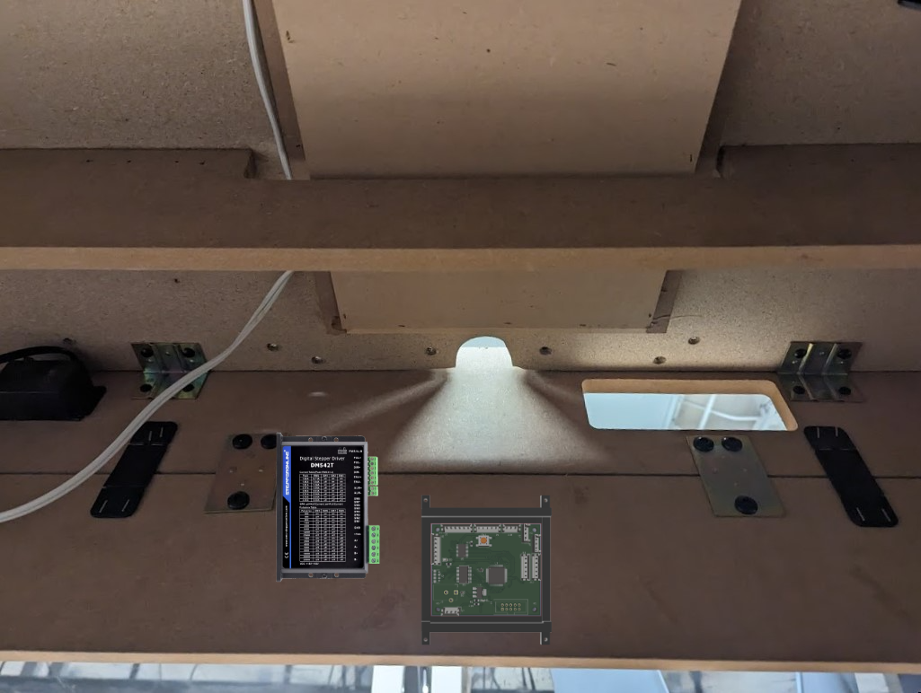

Figure 5

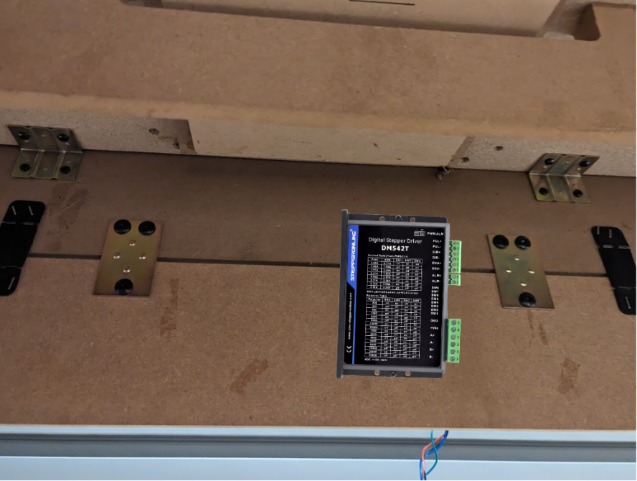

Figure 6

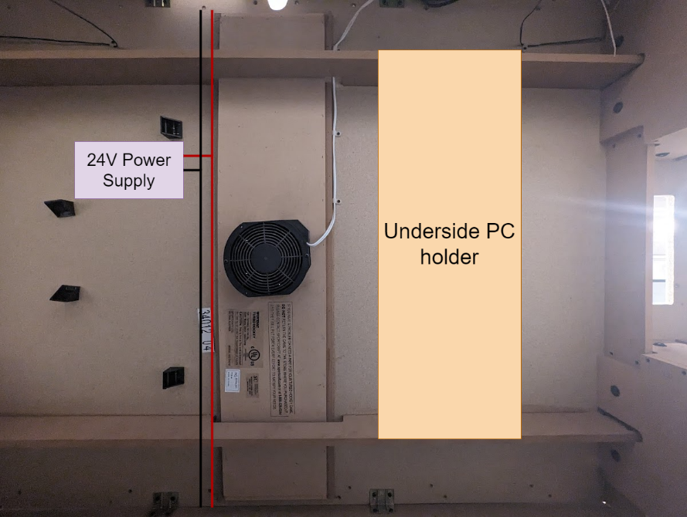

Figure 7

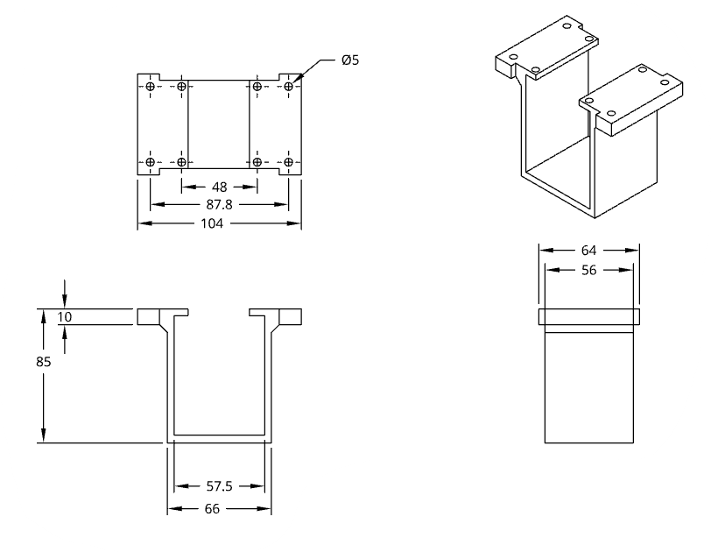

Figure 8

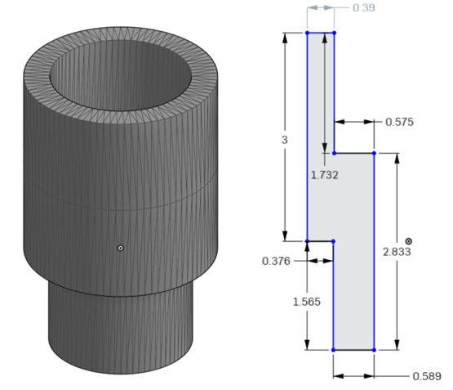

Figure 9

Figure 10

Appendix 2: Project Packaging Specifications

Materials:

|  |  |  |
| --- | --- | --- |
| **Description** | **Weight** | **Cost** |
| CNC Stepper Motor (2) | 1.2kg | $59.98 |
| CNC Stepper Motor Driver (2) | 210g | $51.98 |
| GT2 Pulley 20 Teeth 5 Pack | 26g | $7.99 |
| GT2 Idler Pulley 20 Teeth 10 Pack | 80g | $13.99 |
| Linear Shaft Parts Kits 2 Pcs | 2.1591kg | $63.98 |
| GT2 Timing Belt | 100g | $49.98 |
| Green Hockey Pucks 4 Pack | 40g | $9.99 |
| Air Hockey Table | 120kg | $100 |
| 3D Printer Resin | 500g |  |
| PLA Filament spool (red)(white) | 1kg |  |

Totals: 125.3151kg $358

Tooling Requirements:

* Hammer
* Screwdriver
* CNC
* Glue
* 3D-printer
* Appendix 3: PCB Footprint Layout

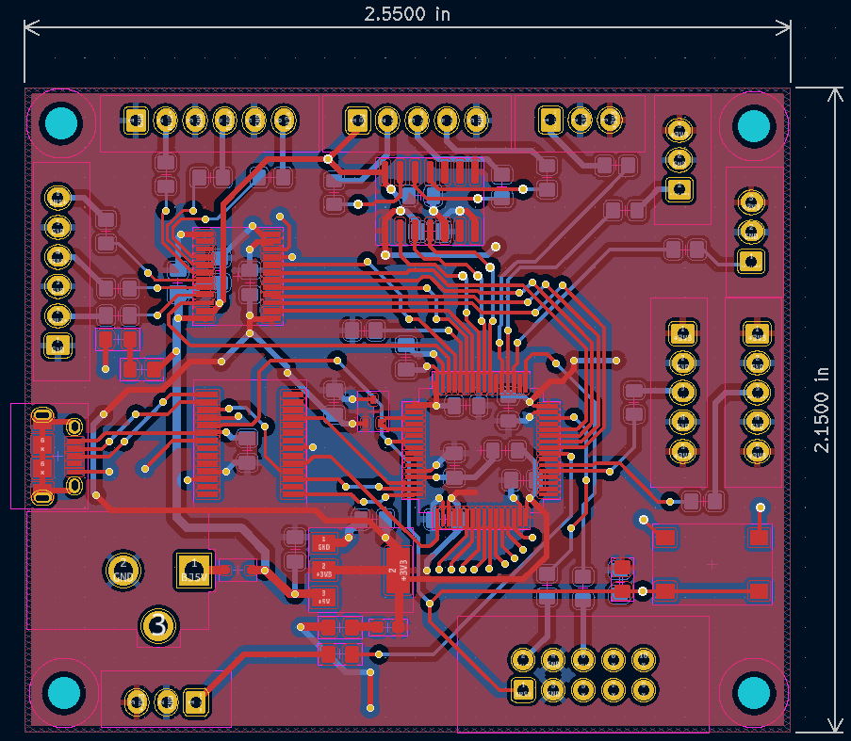

Area: 5.4825in2